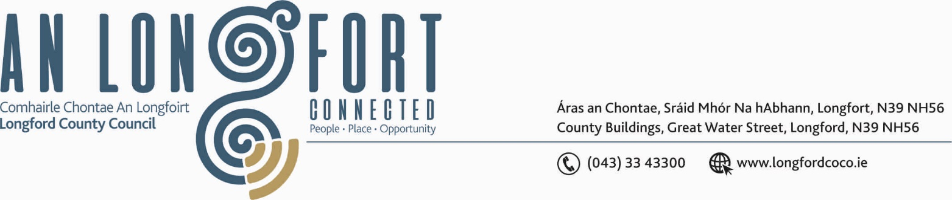

GRANARD MUNICIPAL DISTRICT

Corporate Affairs,
Aras an Chontae,
LONGFOIRT.

18th July 2018.

To: Each Member of Granard Municipal District.

Dear Member,

You are requested to attend Meeting of Granard Municipal District to be held in
Granard Community Library on Tuesday, 24th July 2018 at 3.30 p.m. to transact business, as set out on the Agenda hereunder.

Yours sincerely,
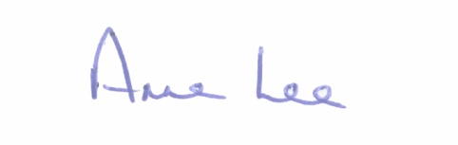

_______________
Anne Lee,
Meetings Administrator.

AGENDA

Prayer before meeting.

1. Confirmation of the following Minutes of Granard Municipal District Meetings -
- 2018 Annual Meeting held on the 22nd May 2018.
- Municipal District Meeting held on the 22nd May 2018

2. Matters arising from Minutes.

3. Area Engineer’s Progress Report.

4. Upgrade of Amenities.

5. Update on the Dolmen in Aughnacliffe.

6. Notices of Motions submitted by Councillors, as listed hereunder. –

Councillor Michael Carrigy.

“I call on Longford County Council to acknowledge the Granard/Ballymore U14 team who recently won their division at the All Ireland Feile Finals.”

Councillor P.J. Reilly.

“That finance to be put in place to complete and open the road between the Old Ulster Bank Granard and Barrack Lane Granard to help solve the problem of heavy traffic turning left at the junction of the Library on Market Street Granard.”

“That resurfacing road works in Granard on the Water Lane and the Crane Yard to be carried out in this year’s Road Plan.”

“That an update be provided regarding the water shortage in Granard, during the recent dry spell.”

::::::::::::::::::::::::::::::::::::

